EXPERIMENT 29:
In your GitHub repository, create a new branch called feature-login. Implement a simple login function in a login.py file. After completing the function, create a pull request to merge feature-login into the main branch.
Tasks:
- Create a new branch feature-login.
- Add a login.py file with a simple login function.
- Commit the changes and push them to GitHub.
- Create a pull request from feature-login to main and merge it.
Step 1: Open the GitHub Repository
- Open the GitHub repository in which the login feature needs to be developed.
- Open Git Bash and navigate to the local repository directory.
- Verify that the repository is up to date with the main branch.
cd ~/Desktop/My-Personal-Project
git status
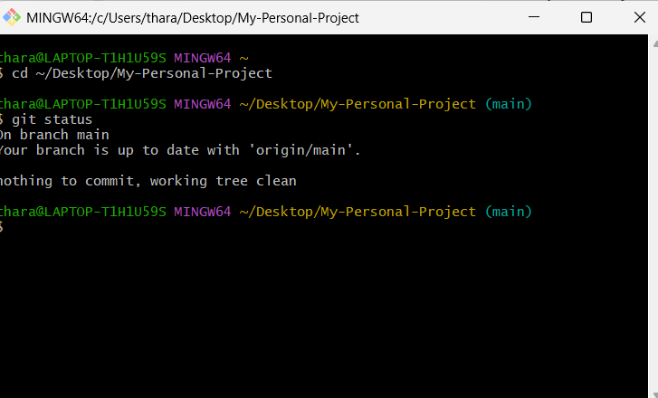

Step 2: Create the Feature Branch
- Create a new branch named feature-login.
- Switch to the newly created branch using the following command.
git checkout -b feature-login
- Verify that the feature branch is active.
git branch
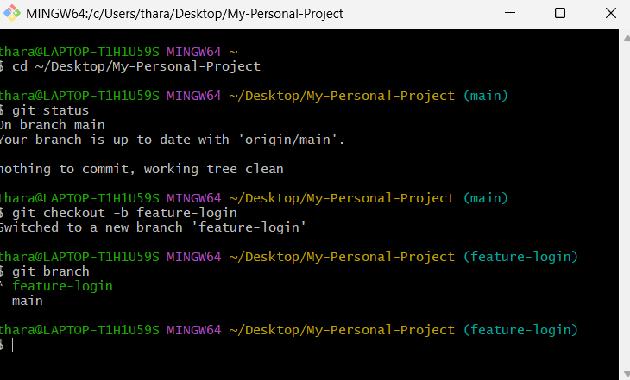
Step 3: Create the Login File
- Open the project in Visual Studio Code.
code .
- Create a new Python file named login.py.
- Add a simple login function that accepts a username and password and validates the credentials.
Example:
def login(username, password):
if username == "admin" and password == "1234":
return "Login successful"
else:
return "Invalid username or password"
- Save the login.py file.
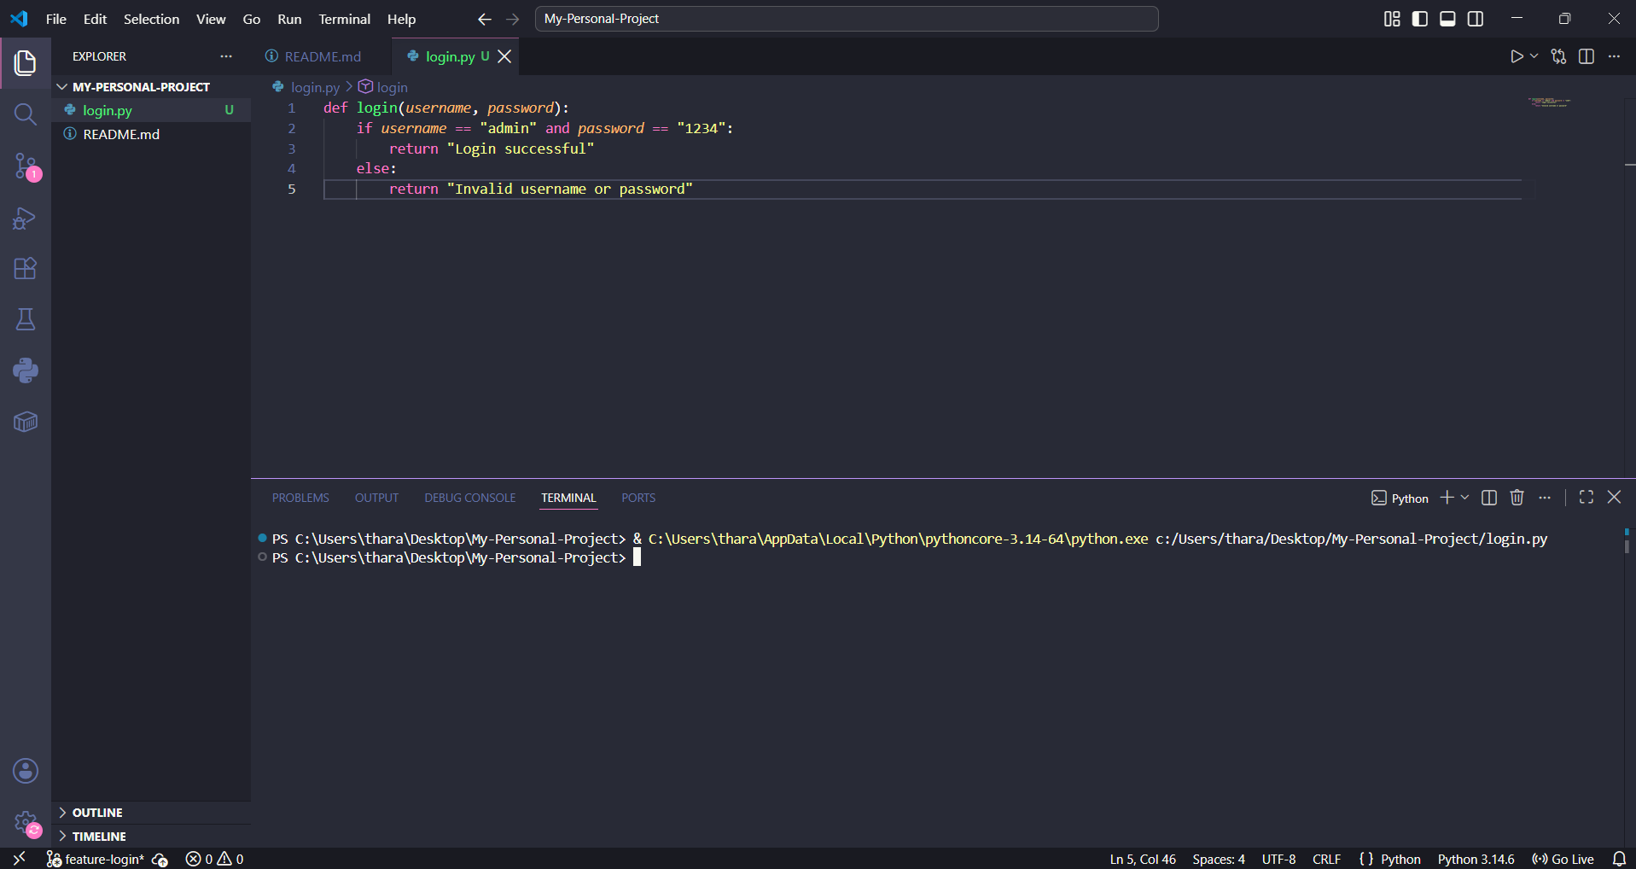
Step 4: Check the Changes
- Return to Git Bash.
- Check the repository status to verify that login.py is detected as a new file.
git status
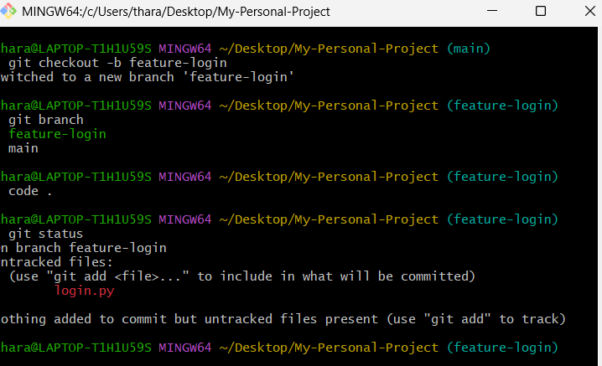
Step 5: Stage and Commit the Changes
- Add the new login.py file to the staging area.
git add login.py
- Commit the changes with a meaningful commit message.
git commit -m "Added login function"
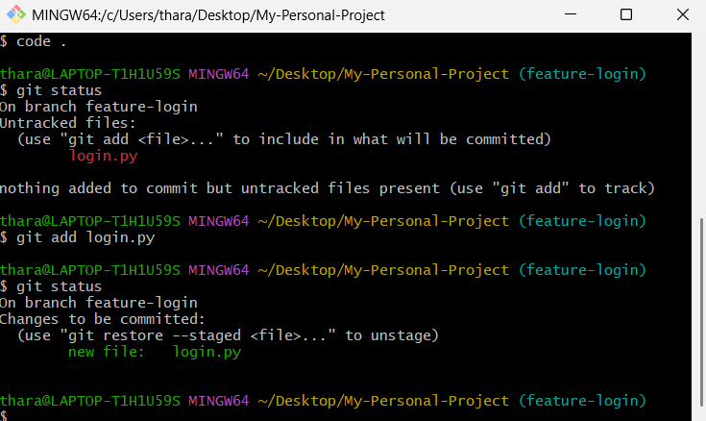
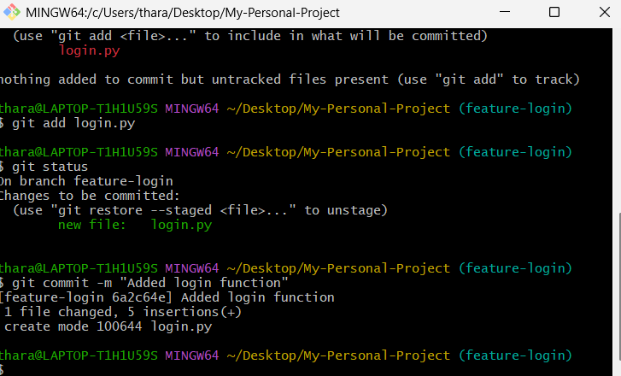
Step 6: Push the Feature Branch
- Push the feature-login branch to the GitHub repository.
git push -u origin feature-login
- Verify that the feature branch is available on GitHub.
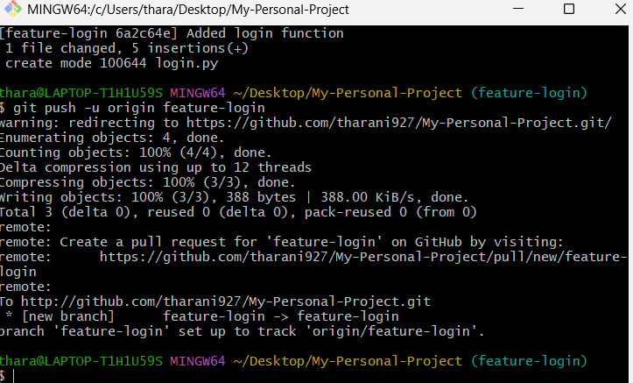

Step 7: Create a Pull Request
- Open the GitHub repository.
- Select the feature-login branch.
- Click Compare & pull request.
- Set the base branch as main and the compare branch as feature-login.
- Enter a suitable title such as Add Login Function.
- Add a brief description of the changes.
- Click Create pull request.
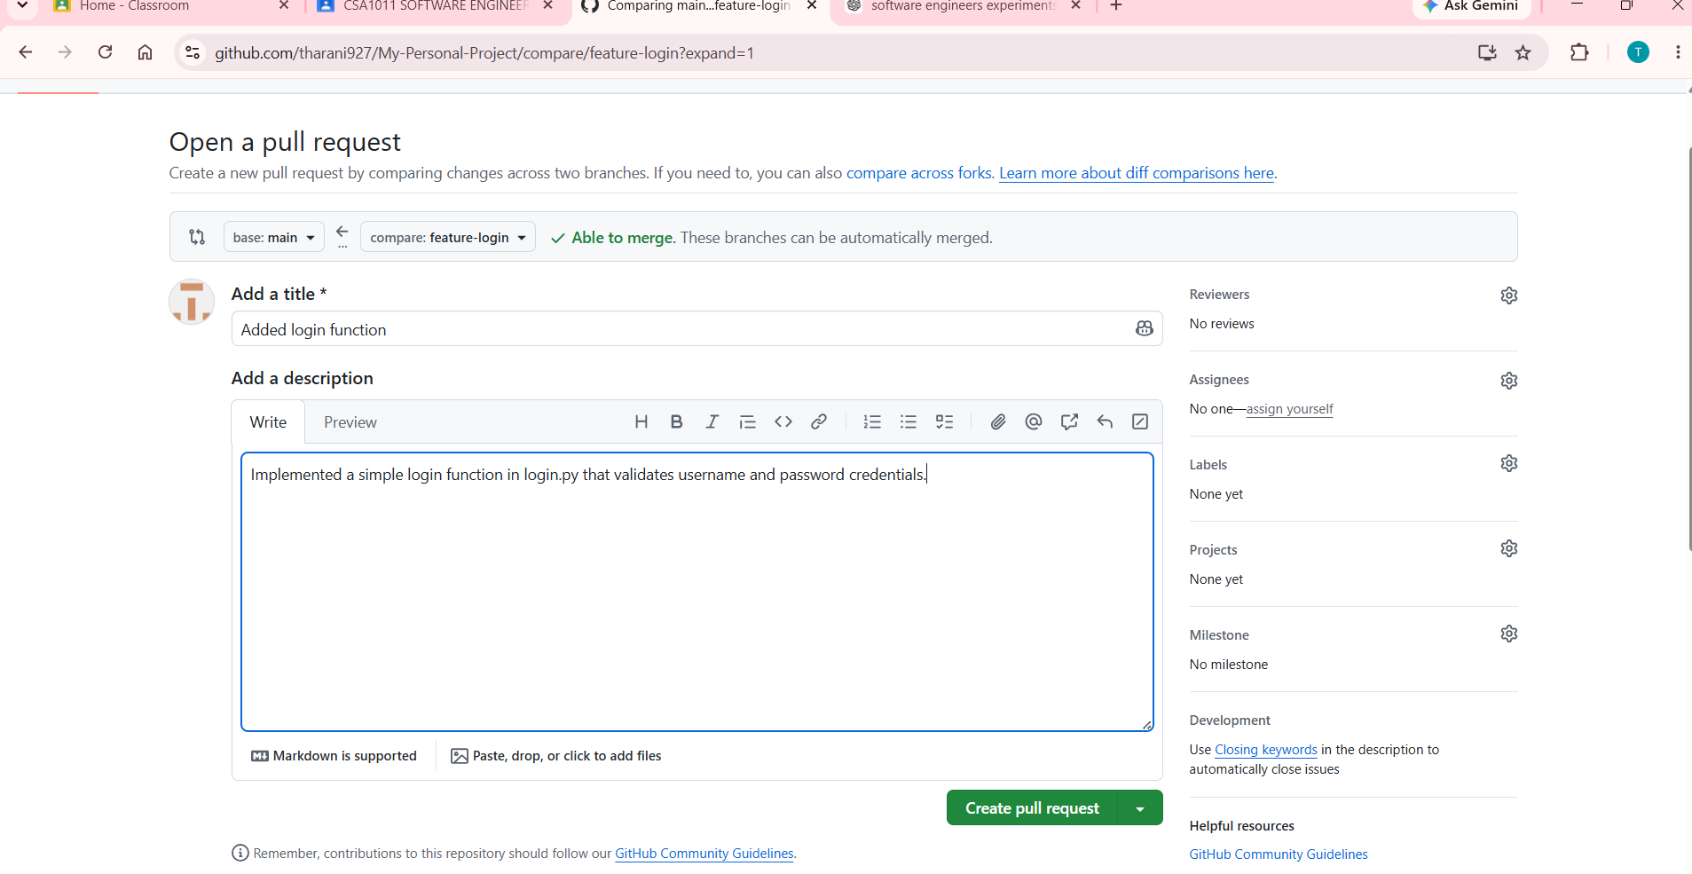
Step 8: Review and Merge the Pull Request
- Review the changes included in the Pull Request.
- Verify that login.py contains the required login function.
- Click Merge pull request.
- Confirm the merge operation.
- Verify that the feature-login changes are now available in the main branch.
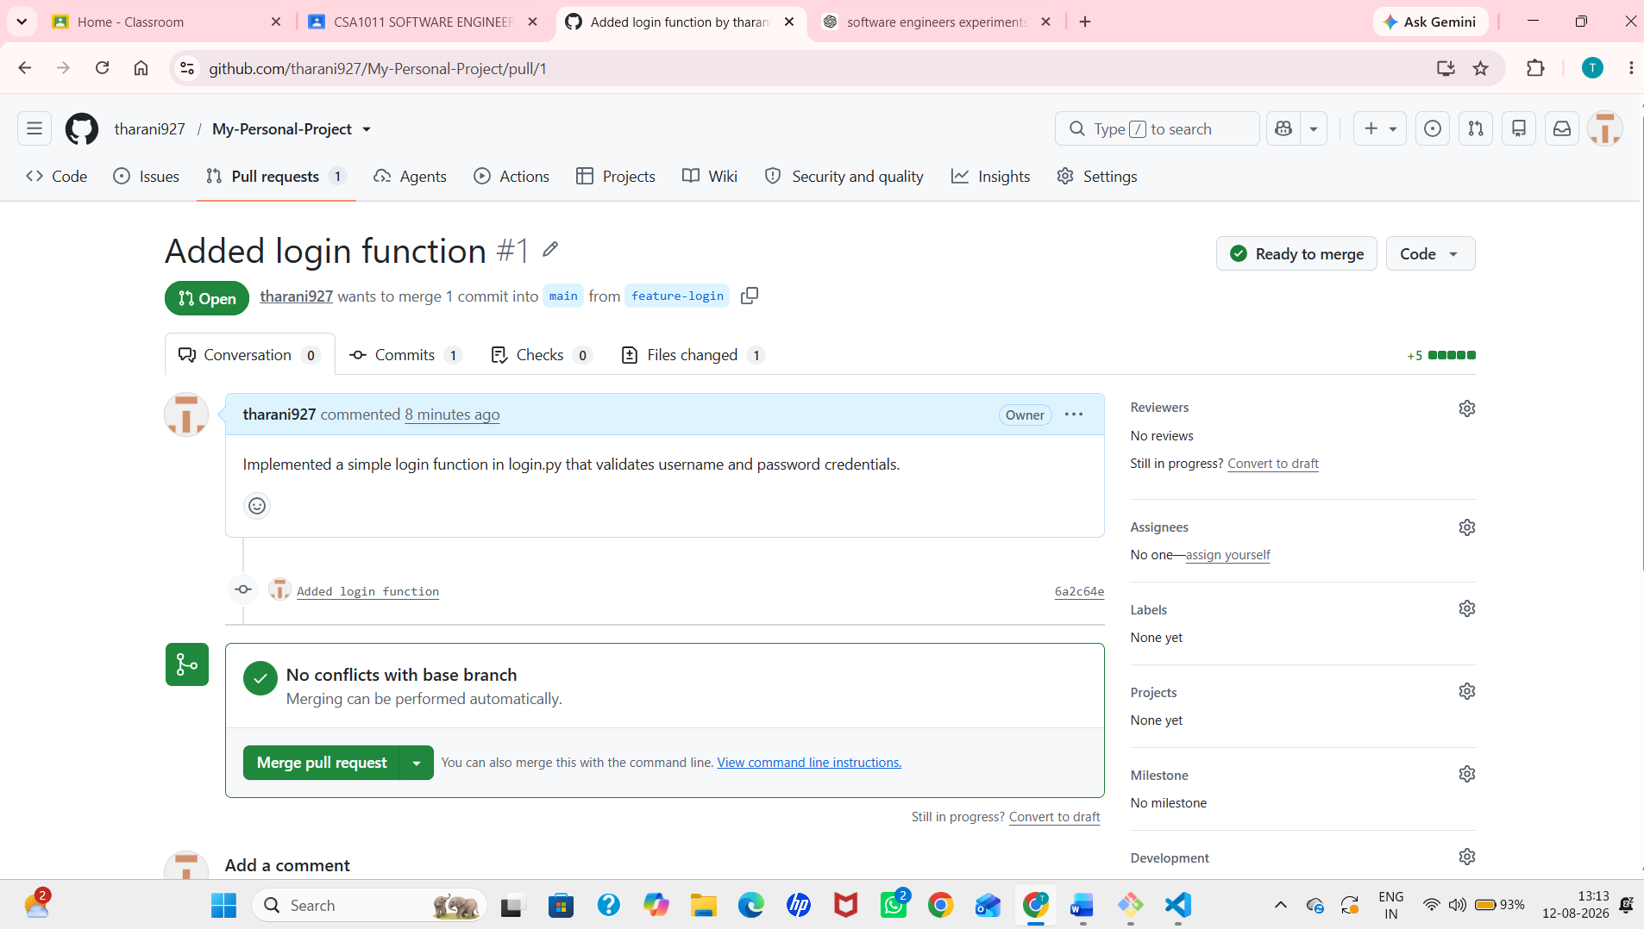
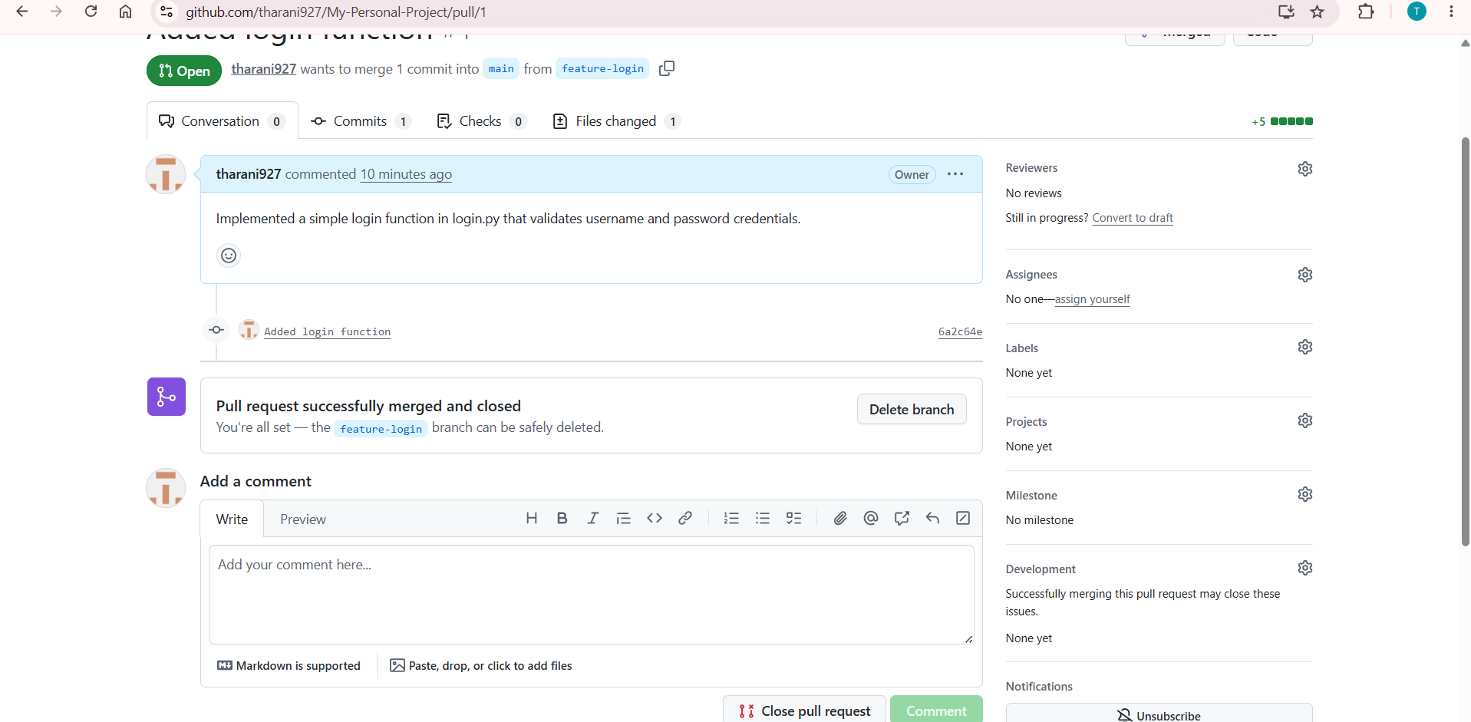
Step 9: Verify the Merged Feature
- Switch to the main branch locally.
git checkout main
- Pull the latest changes from GitHub.
git pull origin main
- Verify that login.py is present in the project.
Ls
